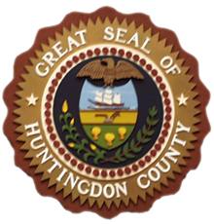
HUNTINGDON COUNTY BOARD OF ELECTIONS
BAILEY BUILDING - 233 PENN STREET
HUNTINGDON, PENNSYLVANIA 16652

PUBLIC NOTICE

Notice is hereby given that on Thursday, October 10, 2024 the Huntingdon County Board of Elections will conduct logic and accuracy testing of the electronic voting equipment to be used at the General Election on November 5, 2024. Testing will continue on subsequent days until completed.
Testing will be conducted in the ballroom of the Bailey Building located at 233 Penn Street, Huntingdon.

